Schematic Wiring Diagram
EcoSand Cleaner: Automated Beach Debris Cleaner

Prepared by:

Dado, Kenneth S.
Fajutagana, Kimberly A.
Balimbingan, Shaina F.
Dacatimban, Kristine Jewel M.
Fernandez, Robyn Kristoffer P.

May 2026

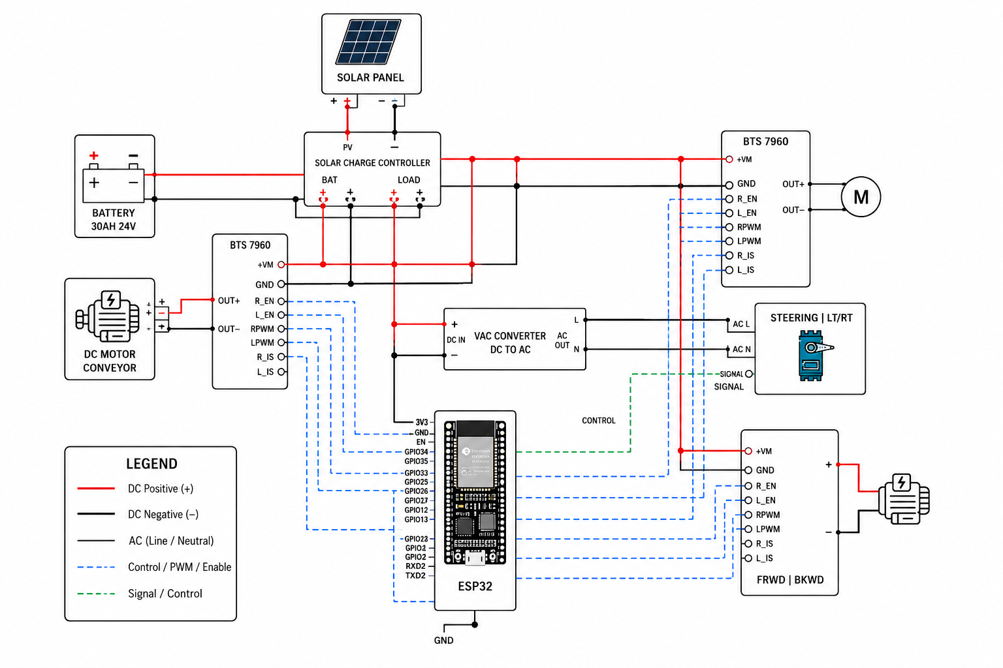
Figure 1: Wiring Diagram
This wiring diagram illustrates a solar-powered automated ground vehicle (AGV) system centered around an ESP32 microcontroller. A solar panel feeds DC power through a solar charge controller, which manages charging for a 30Ah 24V battery while simultaneously supplying regulated power to the rest of the system via its LOAD terminals. DC positive (red) and negative (black) rails distribute power to two BTS 7960 motor driver modules — one driving a DC motor conveyor and another controlling the forward/backward (FRWD/BKWD) drive motor — as well as to a DC-to-AC VAC converter that powers the steering actuator (Steering LT/RT) through its AC Line and Neutral outputs. The ESP32 microcontroller acts as the central controller, with its GPIO pins sending control, PWM, and enable signals (blue dashed lines) to the R_EN, L_EN, RPWM, and LPWM inputs of both BTS 7960 drivers to manage motor speed and direction, while green dashed signal lines connect the ESP32 to both the steering module and the FRWD/BKWD motor driver for directional control. All components share a common ground (GND), with the ESP32 itself grounded through a dedicated GND symbol at its base, ensuring a unified reference voltage across the entire power and control network.

